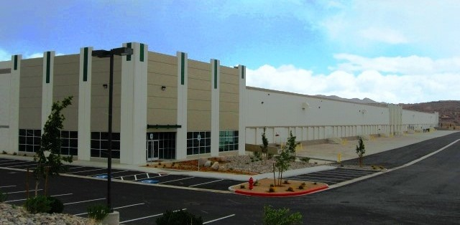

location

* I-80 East Submarket

facility

* 125,875 s.f.
* 3,049 office s.f.
* 21 dock high doors
* 1 drive-in door
* 32’ clear height
* 50’x50’ column spacing w/60’ speed bays
* ESFR sprinkler system
* Front loading
* Available Q3 2022

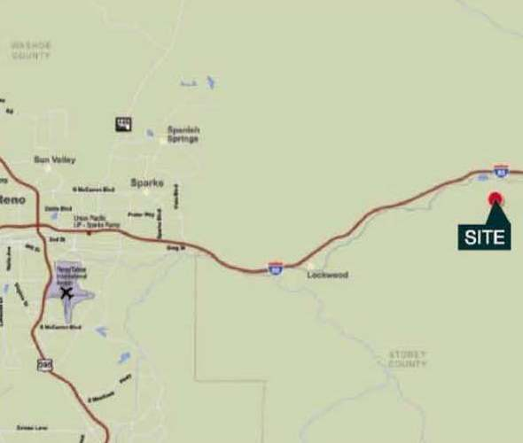



Brian Armon, SIOR, CCIM

[barmon@naialliance.com](mailto:barmon@naialliance.com)

ph +1 775 336 4629

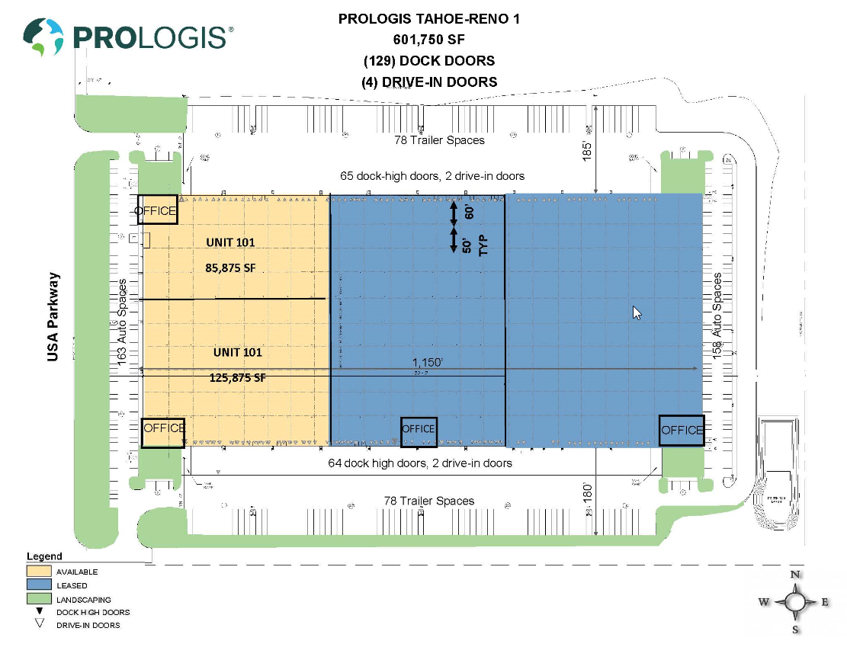



No warranty or representation, expressed or implied, is made as to the accuracy of the information contained herein, and same is submitted subject to error and omissions.

Brian Armon, SIOR, CCIM

[barmon@naialliance.com](mailto:barmon@naialliance.com)

ph + 1 775 336 4629