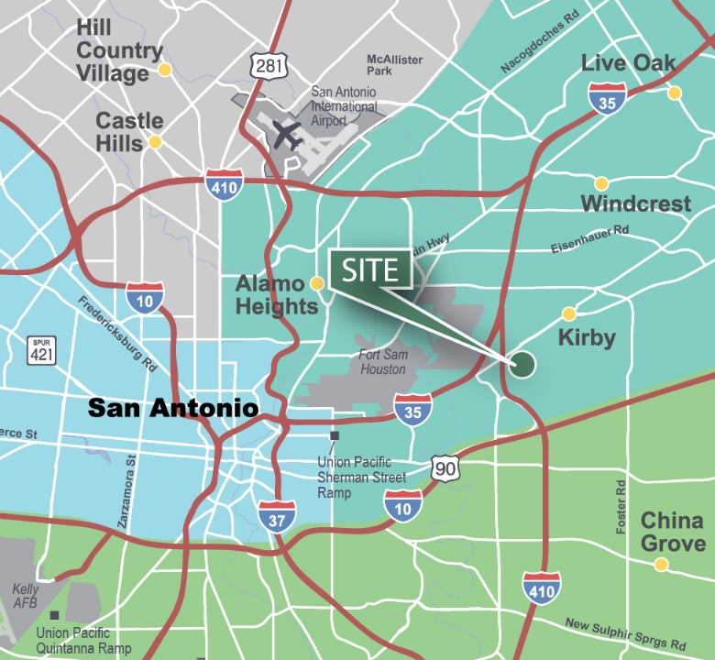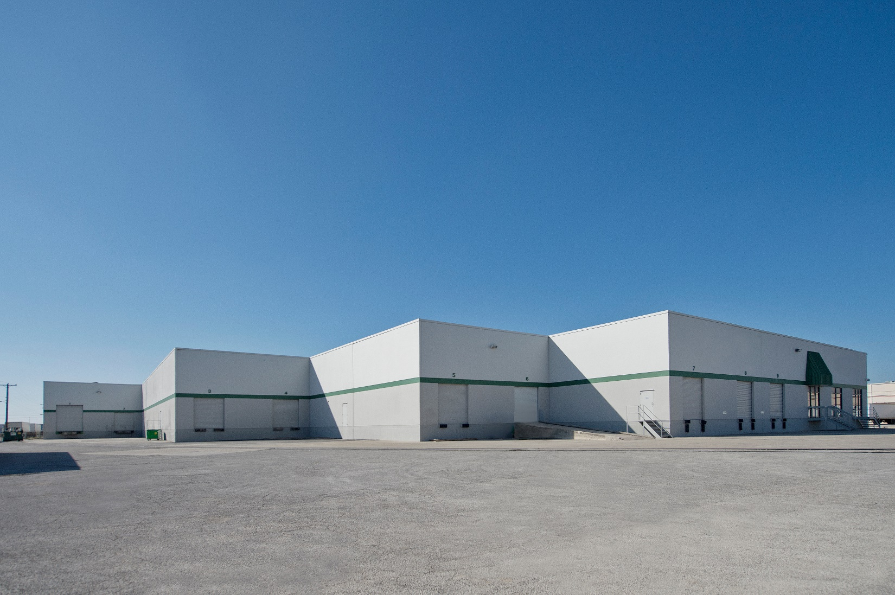

**LOCATION**

* Located near intersection of IH-35 and Loop 410
* Within service area of Fort Sam Houston/San Antonio Military Medical Center and Rittiman Distribution Area
* Approximately 10 miles to San Antonio International Airport

**FACILITY**

* 3,205 SF office
* 22’ clear height
* 40’ x 40’ column spacing
* 7 dock high doors
* 1 grade level ramp
* Fully sprinklered

**ADVANTAGES AND AMENITIES**

* Front load configuration
* Access to the [Prologis Essentials](https://www.prologis.com/what-we-do/prologis-essentials) platform, which includes:
  + [Operations Essentials](https://www.prologis.com/what-we-do/prologis-essentials/operations-essentials)
  + [Workforce Essentials](https://www.prologis.com/what-we-do/prologis-essentials/workforce-essentials)
  + [Transportation Essentials](https://www.prologis.com/what-we-do/prologis-essentials/transporation-essentials)

www.prologis.com

4522 Macro Drive

San Antonio, TX 78218 USA

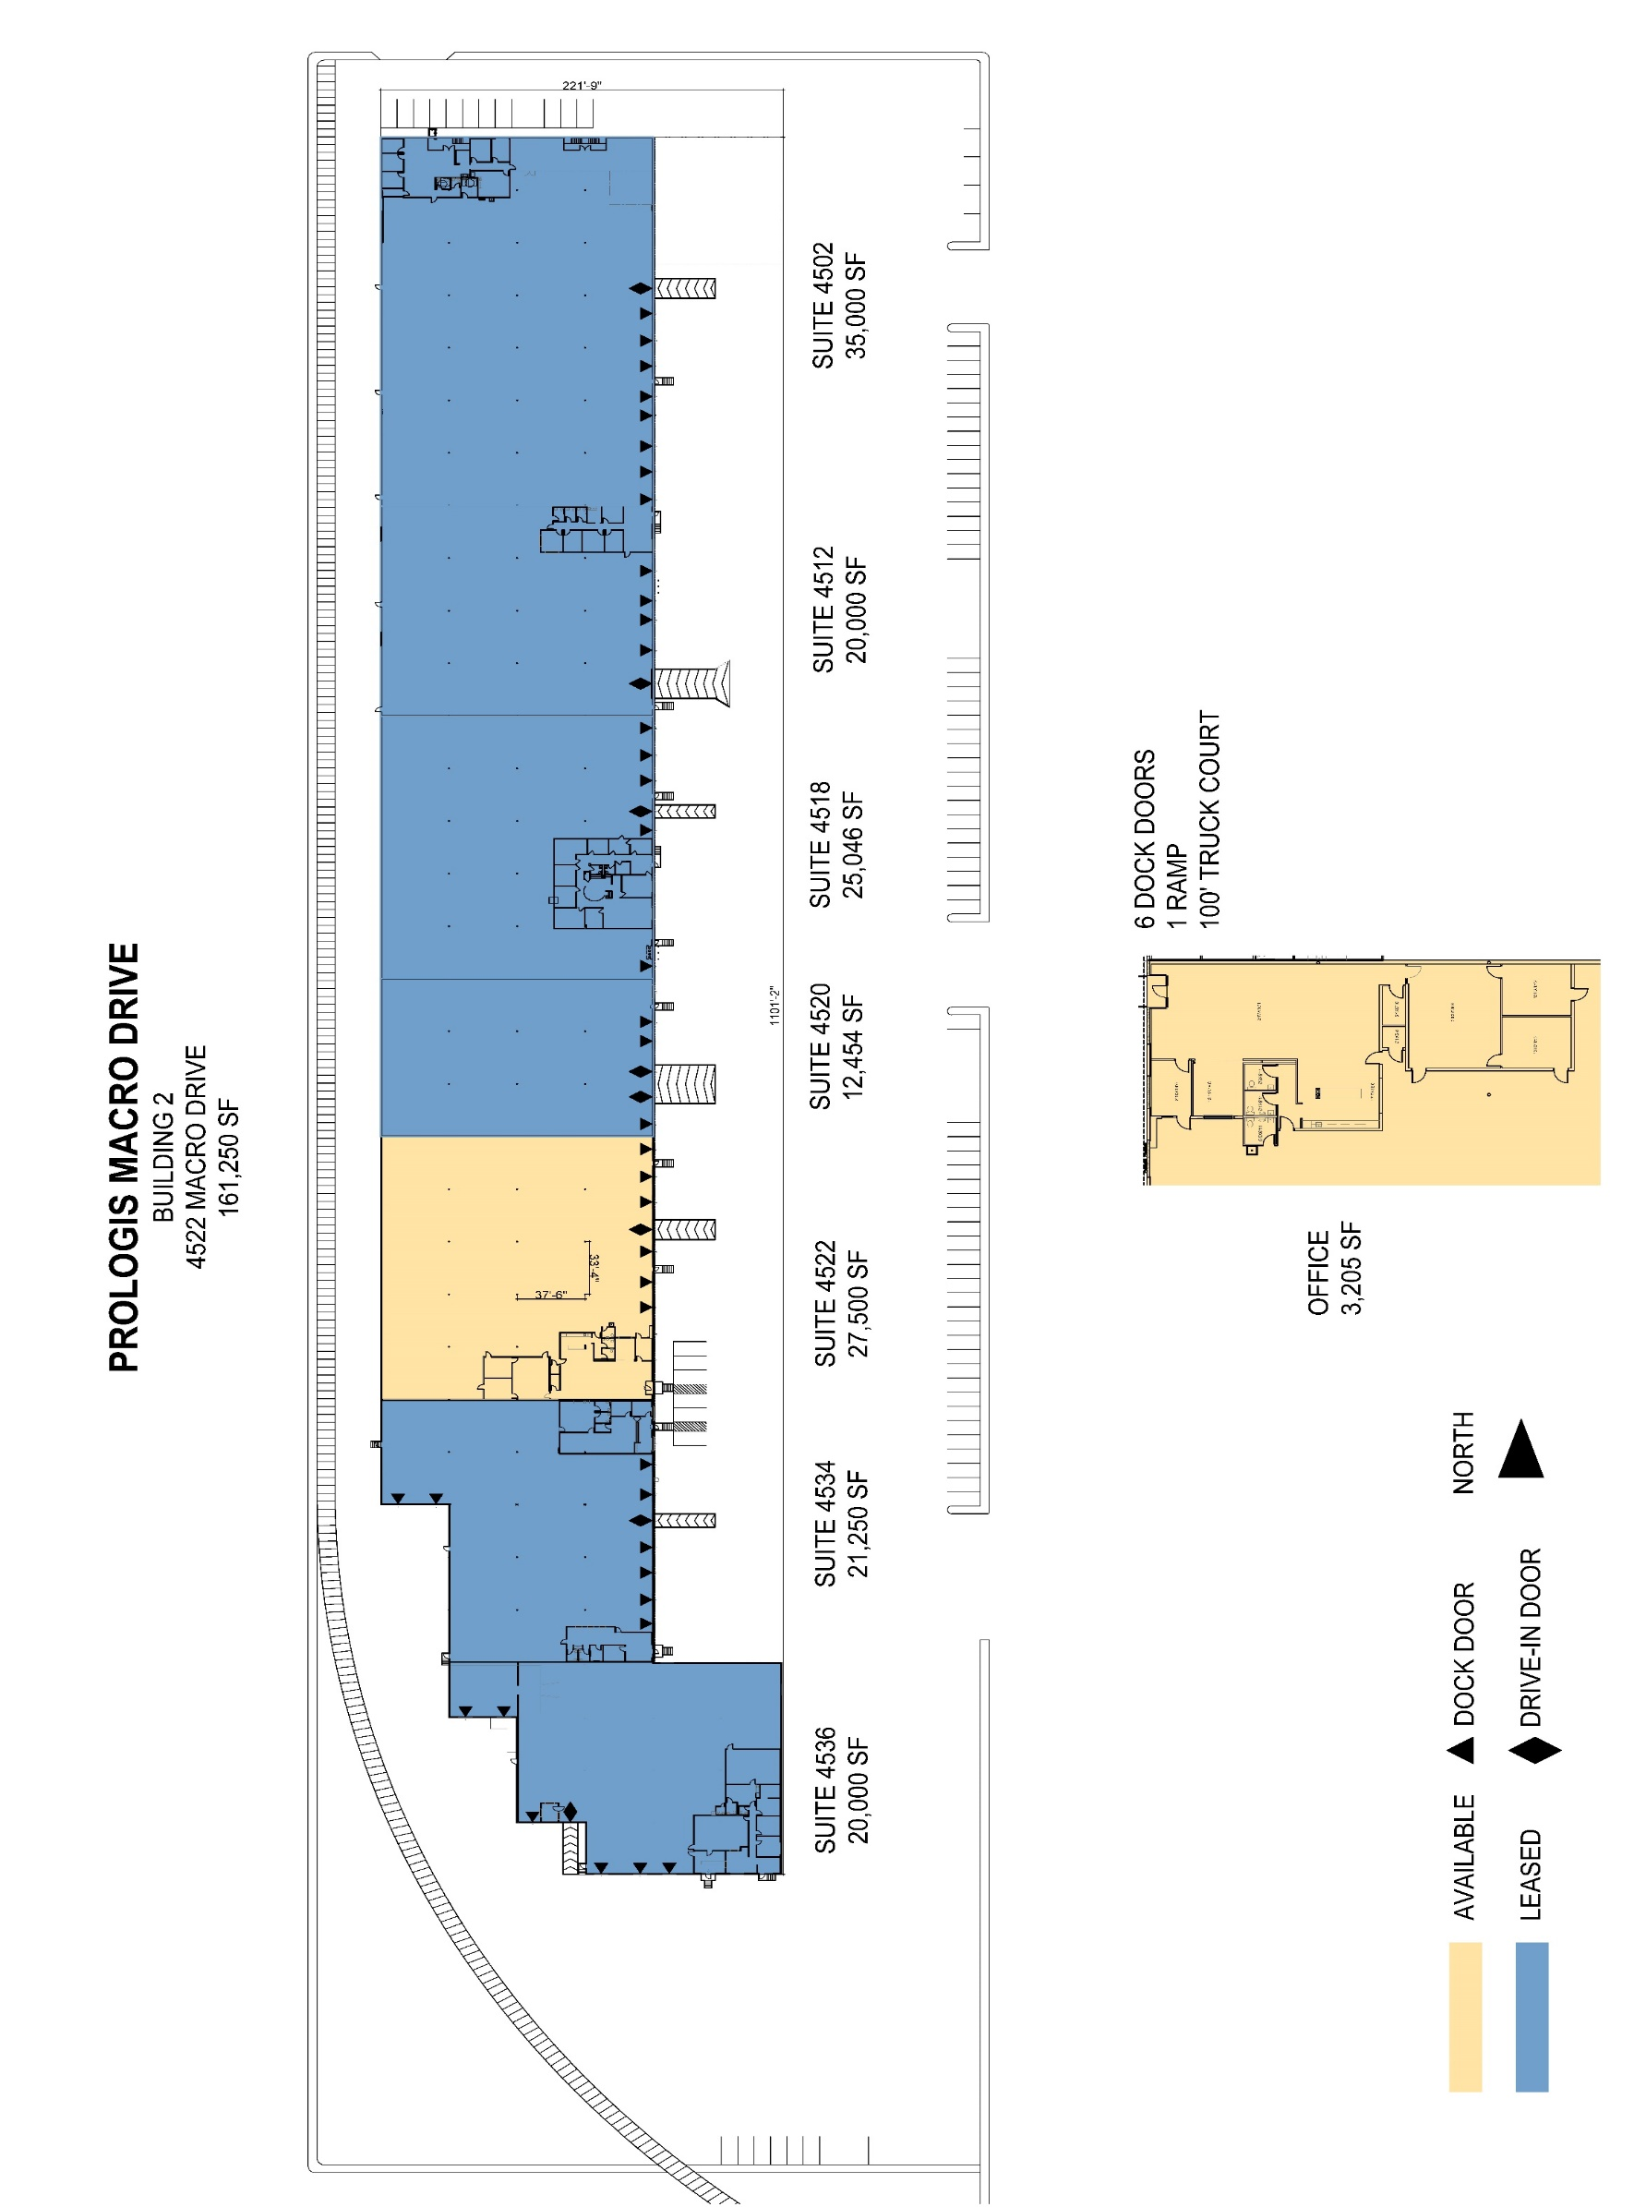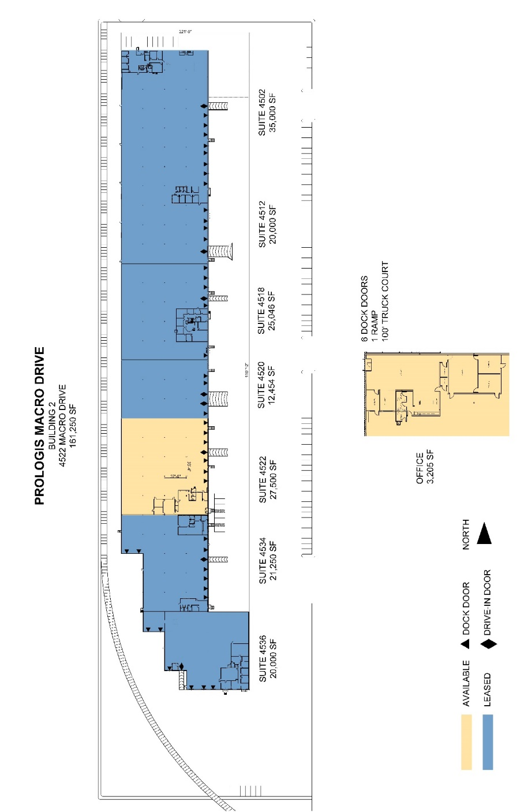

**Stream Realty Partners**

Kevin Cosgrove

Kevin.cosgrove@streamrealty.com

ph +1 210 298 8527

cell +1 210 749 8475

100 Northwest Loop 410

Suite 1500

San Antonio, TX 78216 USA

**Stream Realty Partners**

Payton Rion

payton.rion@streamrealty.comph +1 210 298 8521

cell +1 210 324 1501

100 Northwest Loop 410

Suite 1500

San Antonio, TX 78216 USA

No warranty or representation, expressed or implied, is made as to the accuracy of the information contained herein, and same is submitted subject to error and omissions.

**Prologis**

Whitney Williamson

wwilliamson@prologis.com

ph +1 972 884 9244

cell +1 817 781 5186

200 E Grayson

Suite 116

San Antonio, TX 78215 USA