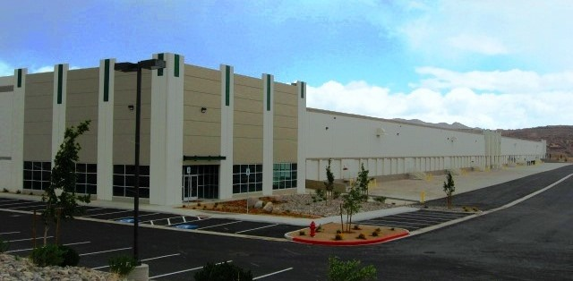

location

* I-80 East Submarket

facility

* 211,750 s.f. available divisible to 85,875 s.f.
* 5,986 Office s.f. total
* 42 dock high doors
* 2 drive-in doors
* 32’ clear height
* 50’x50’ column spacing w/60’ speed bays
* ESFR sprinkler system
* Cross-dock configuration
* 185’ truck court

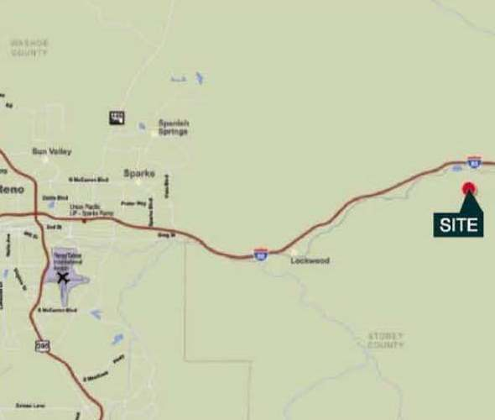



Brian Armon, SIOR, CCIM

[barmon@naialliance.com](mailto:barmon@naialliance.com)

ph +1 775 336 4629

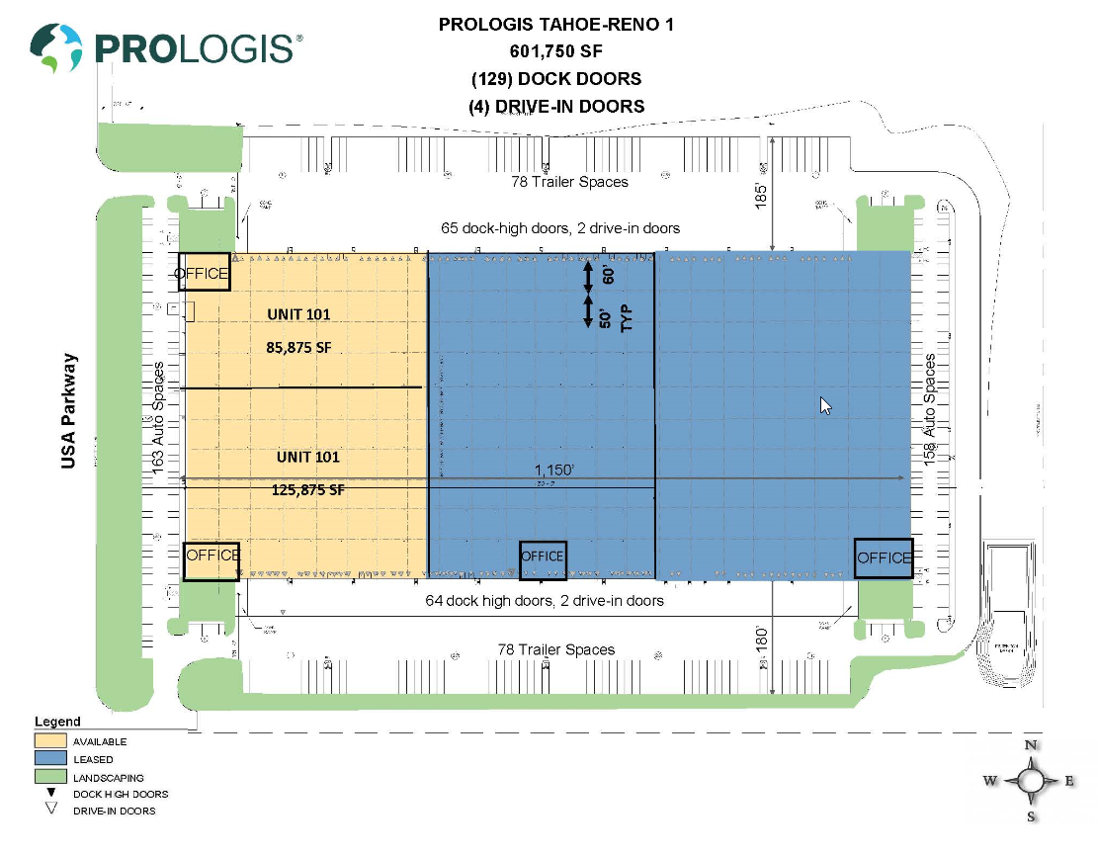



Brian Armon, SIOR, CCIM

[barmon@naialliance.com](mailto:barmon@naialliance.com)

ph + 1 775 336 4629

No warranty or representation, expressed or implied, is made as to the accuracy of the information contained herein, and same is submitted subject to error and omissions.